Rolling correlation: NZDUSD and EURGBP
Method 05 / daily log returns / windows 20, 60, 100 / Low-value

Study setup
Logical pair: NZDUSD , EURGBP
Broker symbols: NZDUSD_i , EURGBP_i
Tier: Low-value (low_value)
Snapshot: 2026-11-03_majors_alpari_D1
Timeframe: D1
Matched return window: 1999-01-06 to 2026-11-02 (UTC bar dates)
Matched return count (rows before rolling): 7183
Dropped unfinished last bar dated 2026-11-03 UTC after a tick-volume check against the prior complete day.
Rolling windows W: 20, 60, 100 trading days
Live-shaped n for each score: n = W (not the full history length)
Complete matched rows (CSV): NZDUSD-EURGBP_Rolling_D1.csv
Complete matched rows (HTML): NZDUSD-EURGBP_Rolling_D1_data.html

Method carried forward
Rolling Pearson r is computed on matched daily log returns of close, ln(close_t / close_t-1), in the broker quote direction. Quotes are not inverted. For each day t with a full window, r_W uses the last W matched return pairs ending at t. That live-shaped sample size is W (20, 60, or 100), not the full multi-year history. The first W-1 days have no score. r is symmetric under swap of the two symbols. A high |r| in one window does not prove cause, lead-lag, or a trading signal. Short windows are noisier; long windows are slower to reflect a break.
How to read a live day: after both daily candles close, the newest r_20 uses the last 20 matched log returns, r_60 the last 60, and r_100 the last 100. Compare those three to each other and to the full-sample baseline below. A break is when the short window moves far from the baseline or flips sign while the baseline was meaningful.

Full-sample Pearson baseline (method 01 v001)
Copied full-sample Pearson r for NZDUSD-EURGBP: 0.037186. This is a historical average link, not the live state.

Rolling results
W | latest_r | mean | median | min | max | std | pct_|r|>=0.4 | pct_|r|>=0.7 | n_roll
20 | -0.272686 | 0.036779 | 0.036329 | -0.768324 | 0.814216 | 0.296263 | 19.82 | 0.92 | 7164
60 | -0.091435 | 0.030252 | 0.034068 | -0.592072 | 0.598675 | 0.224346 | 9.43 | 0 | 7124
100 | -0.165066 | 0.030019 | 0.037242 | -0.553815 | 0.564655 | 0.206823 | 6.17 | 0 | 7084
n_roll is the number of days that had a complete window. pct_|r|>=0.4 and pct_|r|>=0.7 are the share of those days where the absolute rolling correlation cleared the threshold.

Conclusion
For NZDUSD and EURGBP, full-sample Pearson baseline r=0.0372. Latest rolling scores: r_20=-0.2727, r_60=-0.0914, r_100=-0.1651. Stability: moderate window-to-window variation. Agreement with baseline: r_20=-0.273 opposite sign vs baseline; r_60=-0.091 opposite sign vs baseline; r_100=-0.165 opposite sign vs baseline. Tier line: low interest historically; check only if a short window spikes. This is a monitoring summary, not a trade signal.

What to look at in this file next time
1) Latest r_20 vs r_60 vs r_100 in the results table. 2) Whether short-window latest has the same sign as the baseline. 3) The rolling chart for stretches where |r| collapsed. 4) The CSV if you need a different chart later.

Charts
Rolling Pearson r (20 / 60 / 100)
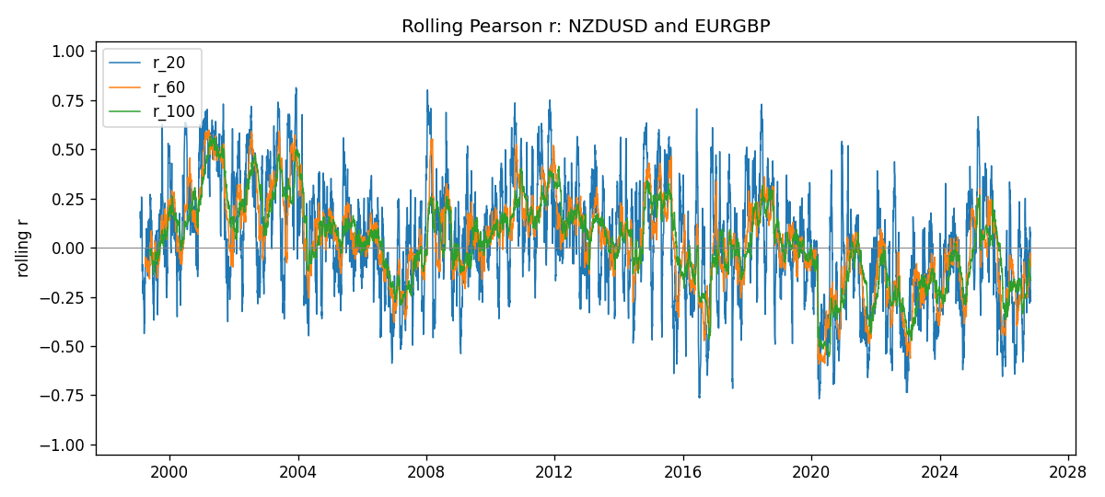
Daily closes

Daily log returns
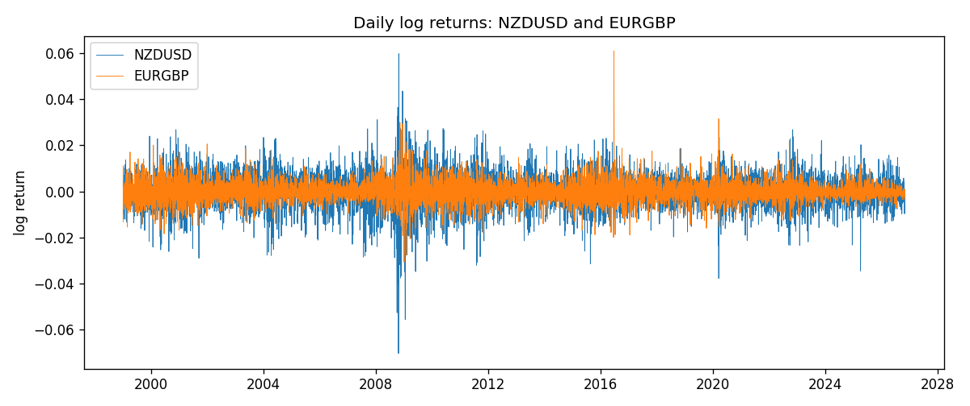

Data report
Every matched row with r_20, r_60, and r_100 is in the sibling CSV and HTML. This Word section holds column summaries and the first and last 15 rows of the rolling table.
Columns: time, NZDUSD_close, EURGBP_close, NZDUSD_tick_volume, EURGBP_tick_volume, NZDUSD_log_return, EURGBP_log_return, r_20, r_60, r_100
Column summaries
column | count | mean | std | min | 25% | 50% | 75% | max
NZDUSD_close | 7183 | 0.656544 | 0.108177 | 0.3907 | 0.59181 | 0.6685 | 0.72502 | 0.8822
EURGBP_close | 7183 | 0.786987 | 0.0966947 | 0.5735 | 0.68775 | 0.83395 | 0.86536 | 0.977
NZDUSD_tick_volume | 7183 | 68736.6 | 123153 | 16 | 5594.5 | 33901 | 58513.5 | 1.12768e+06
EURGBP_tick_volume | 7183 | 87133.2 | 145500 | 154 | 6553 | 44358 | 81413 | 1.42468e+06
NZDUSD_log_return | 7183 | 1.073e-05 | 0.0076464 | -0.0702743 | -0.00425909 | 0.00022967 | 0.00458236 | 0.0596684
EURGBP_log_return | 7183 | 2.33e-05 | 0.00487088 | -0.0306737 | -0.00262163 | -9.879e-05 | 0.002558 | 0.0607539
r_20 | 7164 | 0.0367786 | 0.296263 | -0.768324 | -0.165691 | 0.0363287 | 0.235939 | 0.814216
r_60 | 7124 | 0.0302525 | 0.224346 | -0.592072 | -0.103199 | 0.034068 | 0.168887 | 0.598675
r_100 | 7084 | 0.0300195 | 0.206823 | -0.553815 | -0.0995964 | 0.037242 | 0.162807 | 0.564655
First 15 matched rows
time | NZDUSD_close | EURGBP_close | NZDUSD_log_return | EURGBP_log_return | r_20 | r_60 | r_100
1999-01-06 | 0.5383 | 0.7019 | 0.00204556 | -0.0133033
1999-01-07 | 0.5417 | 0.7097 | 0.00629632 | 0.0110514
1999-01-08 | 0.5414 | 0.7062 | -0.000553965 | -0.00494386
1999-01-11 | 0.547 | 0.7053 | 0.0102904 | -0.00127524
1999-01-12 | 0.5441 | 0.7077 | -0.00531575 | 0.00339703
1999-01-13 | 0.5387 | 0.708 | -0.00997422 | 0.000423819
1999-01-14 | 0.5386 | 0.7066 | -0.000185649 | -0.00197936
1999-01-15 | 0.5382 | 0.7012 | -0.000742942 | -0.00767158
1999-01-18 | 0.5372 | 0.7017 | -0.00185977 | 0.000712809
1999-01-19 | 0.5382 | 0.7007 | 0.00185977 | -0.00142613
1999-01-20 | 0.5404 | 0.7021 | 0.00407937 | 0.00199601
1999-01-21 | 0.5426 | 0.7016 | 0.00406279 | -0.000712403
1999-01-22 | 0.5361 | 0.7004 | -0.0120517 | -0.00171184
1999-01-25 | 0.5342 | 0.6966 | -0.00355041 | -0.00544024
1999-01-26 | 0.5381 | 0.6962 | 0.00727412 | -0.000574383
Last 15 matched rows
time | NZDUSD_close | EURGBP_close | NZDUSD_log_return | EURGBP_log_return | r_20 | r_60 | r_100
2026-10-13 | 0.56127 | 0.84458 | 0.00473262 | 0.000201304 | 0.0212668 | -0.0754047 | -0.0598409
2026-10-14 | 0.55918 | 0.84553 | -0.00373065 | 0.00112419 | 0.0366288 | -0.0797674 | -0.0836993
2026-10-15 | 0.56185 | 0.84479 | 0.00476349 | -0.000875574 | -0.114899 | -0.0620249 | -0.0947898
2026-10-16 | 0.56509 | 0.84307 | 0.0057501 | -0.00203808 | -0.185696 | -0.0824683 | -0.110041
2026-10-19 | 0.56616 | 0.84259 | 0.00189171 | -0.00056951 | -0.173263 | -0.0732681 | -0.133353
2026-10-20 | 0.56827 | 0.83957 | 0.00371993 | -0.00359063 | -0.282887 | -0.115254 | -0.148166
2026-10-21 | 0.57003 | 0.83839 | 0.00309233 | -0.00140647 | -0.0510259 | -0.129029 | -0.138296
2026-10-22 | 0.56815 | 0.83682 | -0.00330352 | -0.00187439 | 0.0416353 | -0.0606406 | -0.133827
2026-10-23 | 0.56991 | 0.83751 | 0.00309299 | 0.00082421 | 0.104474 | -0.0438582 | -0.147484
2026-10-26 | 0.56826 | 0.83762 | -0.00289939 | 0.000131333 | 0.0571152 | -0.0266614 | -0.152723
2026-10-27 | 0.56811 | 0.83595 | -0.000263999 | -0.00199573 | 0.079956 | -0.0370054 | -0.149224
2026-10-28 | 0.56261 | 0.83651 | -0.00972839 | 0.000669672 | -0.14089 | -0.0596041 | -0.155596
2026-10-29 | 0.56296 | 0.83553 | 0.000621907 | -0.00117222 | -0.240093 | -0.0693958 | -0.163301
2026-10-30 | 0.56307 | 0.83351 | 0.000195377 | -0.00242055 | -0.217094 | -0.077964 | -0.163495
2026-11-02 | 0.56161 | 0.83426 | -0.0025963 | 0.000899405 | -0.272686 | -0.0914347 | -0.165066

